- Ladre is a small scaled family business found in 2000s which selling computers’ hardware and software. Recently the shop owner plans to improve the business by selling the products online. He has contacted your company as a suitable software house to handle this project.
Discuss the 3 main activities that your team would perform for the architectural design of the above project.

Tutor answer:
- System Organization / Structuring
The Ladre online computer store system is structured into (Repository model / Client-server model / Layered model) by number of principal sub-systems and communications between sub-systems in share data, how they are distributed and interface with each other.

- Modular Decomposition
The decomposition of Ladre online computer store sub-systems into modules by using (Object-Oriented Decomposition / Function-Oriented Decomposition)

- Control Modeling
Ladre online computer store sub-systems must be controlled so that their services are delivered to the right place at the right time by using (Centralized control / Event-based control)

- You, as a project manager have been assigned to lead project team e-learning system for a college. The main functions of the e-learning system include programme registration and payment, on-line assessment, assignment submission, uploading and downloading course materials. The main campus of the college is located at Penang and the other branch campuses are located in Melaka, Kelantan and Sarawak.

Recommend and draw an appropriate system organization model for the above project. Explain the model and justify your recommendation.

Tutor answer:

Client server with repository model
- Repository: to share large datas like programme details, course details, students details, staff details among subsystems.
- Client-server: the processing of heavy transaction from online user of the system distributed across subsystem to avoid overloaded situation, etc during registering, expected huge transaction from students (online user) at the same period of time. In order to avoid overloaded situation, client server model is used.
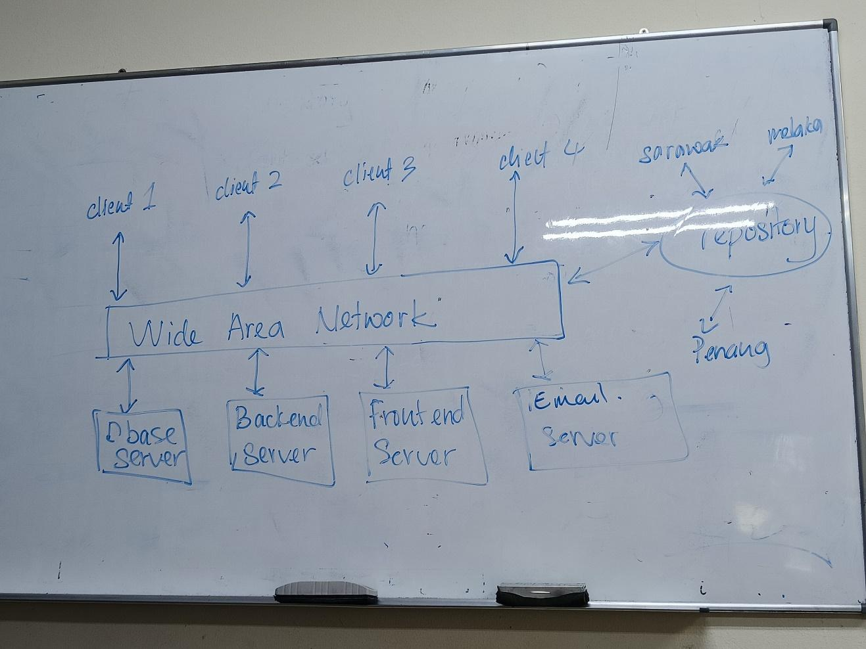

- Differentiate the following pairs of control model:

- Call-return model and manager model

Tutor answer:
- Call-return model
  - A top down sub-routine model
  - Applicable for sequential systems
- Manager model
  - A system component is designated as system manager
  - Processes (sub-system) can execute concurrently
  - Applicable for concurrent systems

- Interrupt-driven model and broadcast model

Tutor answer:
- Interrupt-driven model
  - Used in real-time systems where interrupts are detected by an interrupt handler and passed to some other component for processing.
- Broadcast model
  - An event is broadcast to all sub-systems. Any sub-system which can handle the event may respond to it.
  - Effective in integrating sub-systems distributed across different computers on a network.

- Giving reasons for your answer, suggest an appropriate system organization model for the following systems:

- An automated ticket issuing system used by customers at a cinema.

Tutor answer:
- Repository model – share data like movie information among the sub-systems.

- A Sales and Inventory System used by Sales Staff and Inventory Staff in an organization

Tutor answer:
- Client-server with repository
  - Client server – to avoid overloaded transaction situation during peak sales
  - Repository – to share inventory details among the sub system

- A Sales Invoicing System will firstly take the customer order transactions and itemize unit price from database, follow by totaling up all the items ordered prices to calculate the invoice amount. The system will then deduct the invoice amount with a discounted rate (if any) and this will produce the final invoice amount. Then the system will update the customer account and finally print the invoice for each customer.

Giving reasons for your answer suggest a suitable control model for the above system. You may state any assumptions to support your answer.

Tutor answer:
- Call return model – suitable for sequential systems where by customer order transactions and itemize unit price from database then totalling up all the items ordered prices to calculate the invoice amount then deduct the invoice amount with a discounted rate finally product invoice amount.

- XinJin Press is a newspaper company which started its first printed newspaper in 1960s. Recently, you are invited to attend a discussion meeting with XinJin Company’s IT department. The main agenda of the meeting is to decide on the maintenance of some of their legacy systems. One of their legacy systems is a text file storage server which stores large amount of the newspaper draft contents (original story from the interview, news draft, supporting images or news, and et cetera). The file storage system has no documentation and no proper module design. The draft contents might be useful in the future to trace the original story.

Assuming that XinJin IT department decided to re-engineer the legacy system. Propose 1 system organization/structuring design model. Explain and justify your answer.

Tutor anwer:
- Repository model – share data -> large amount of data like newspaper draft contents, original story from the interview, news draft, supporting images or news, and et cetera need to share among sub system.

- Easy2Study.com is a global marketplace for teaching and learning online where students are mastering their skills. The system allows the students to search, view available courses, purchase, make payment, and join the courses. An access to start the course will be given once the payment is confirmed. Easy2Study.com is planning to extend their online system on mobile platforms to attract more customers as mobile users are increasing extremely.

Suggest and explain 1 suitable system organization model and 1 control modelling model for the Easy2Study.com mobile application. Discuss your answers.

Tutor answer:
- System organizations model – client server / client server with repository

- Control model – manager model – one subsystem act as manager responsible for control start and stop other sub systems which handling search, view available course, purchase, join course and make a payment.

